4a. LG1
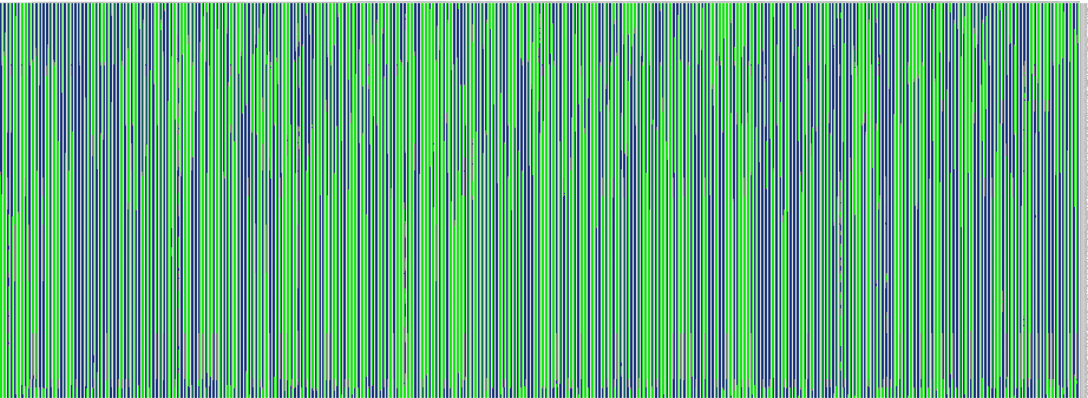

4b. LG2

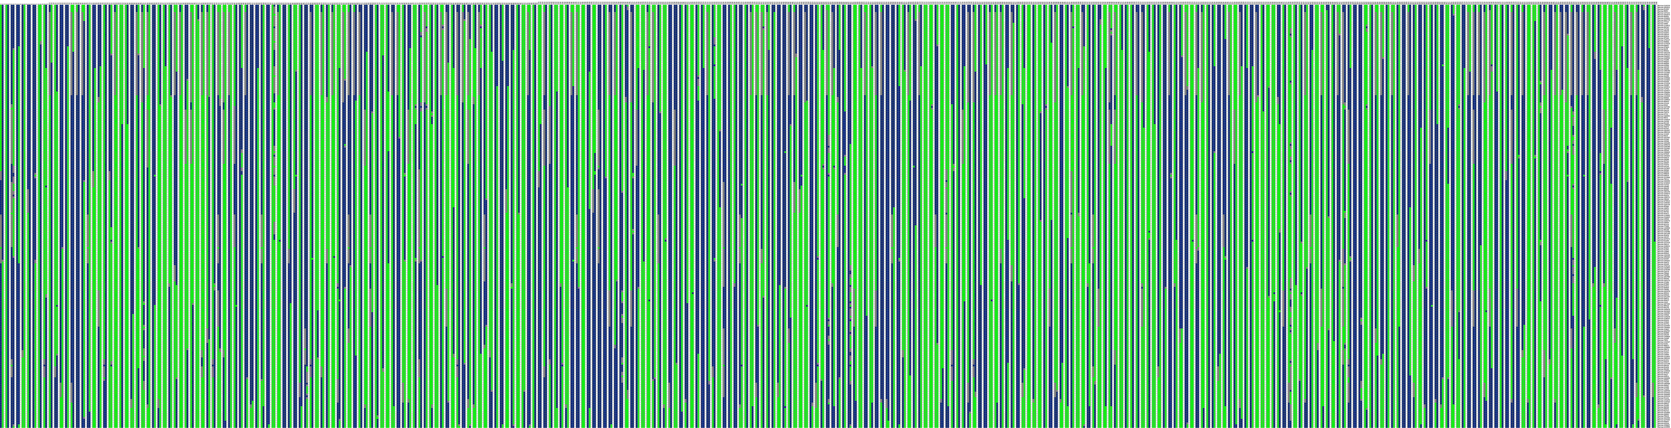

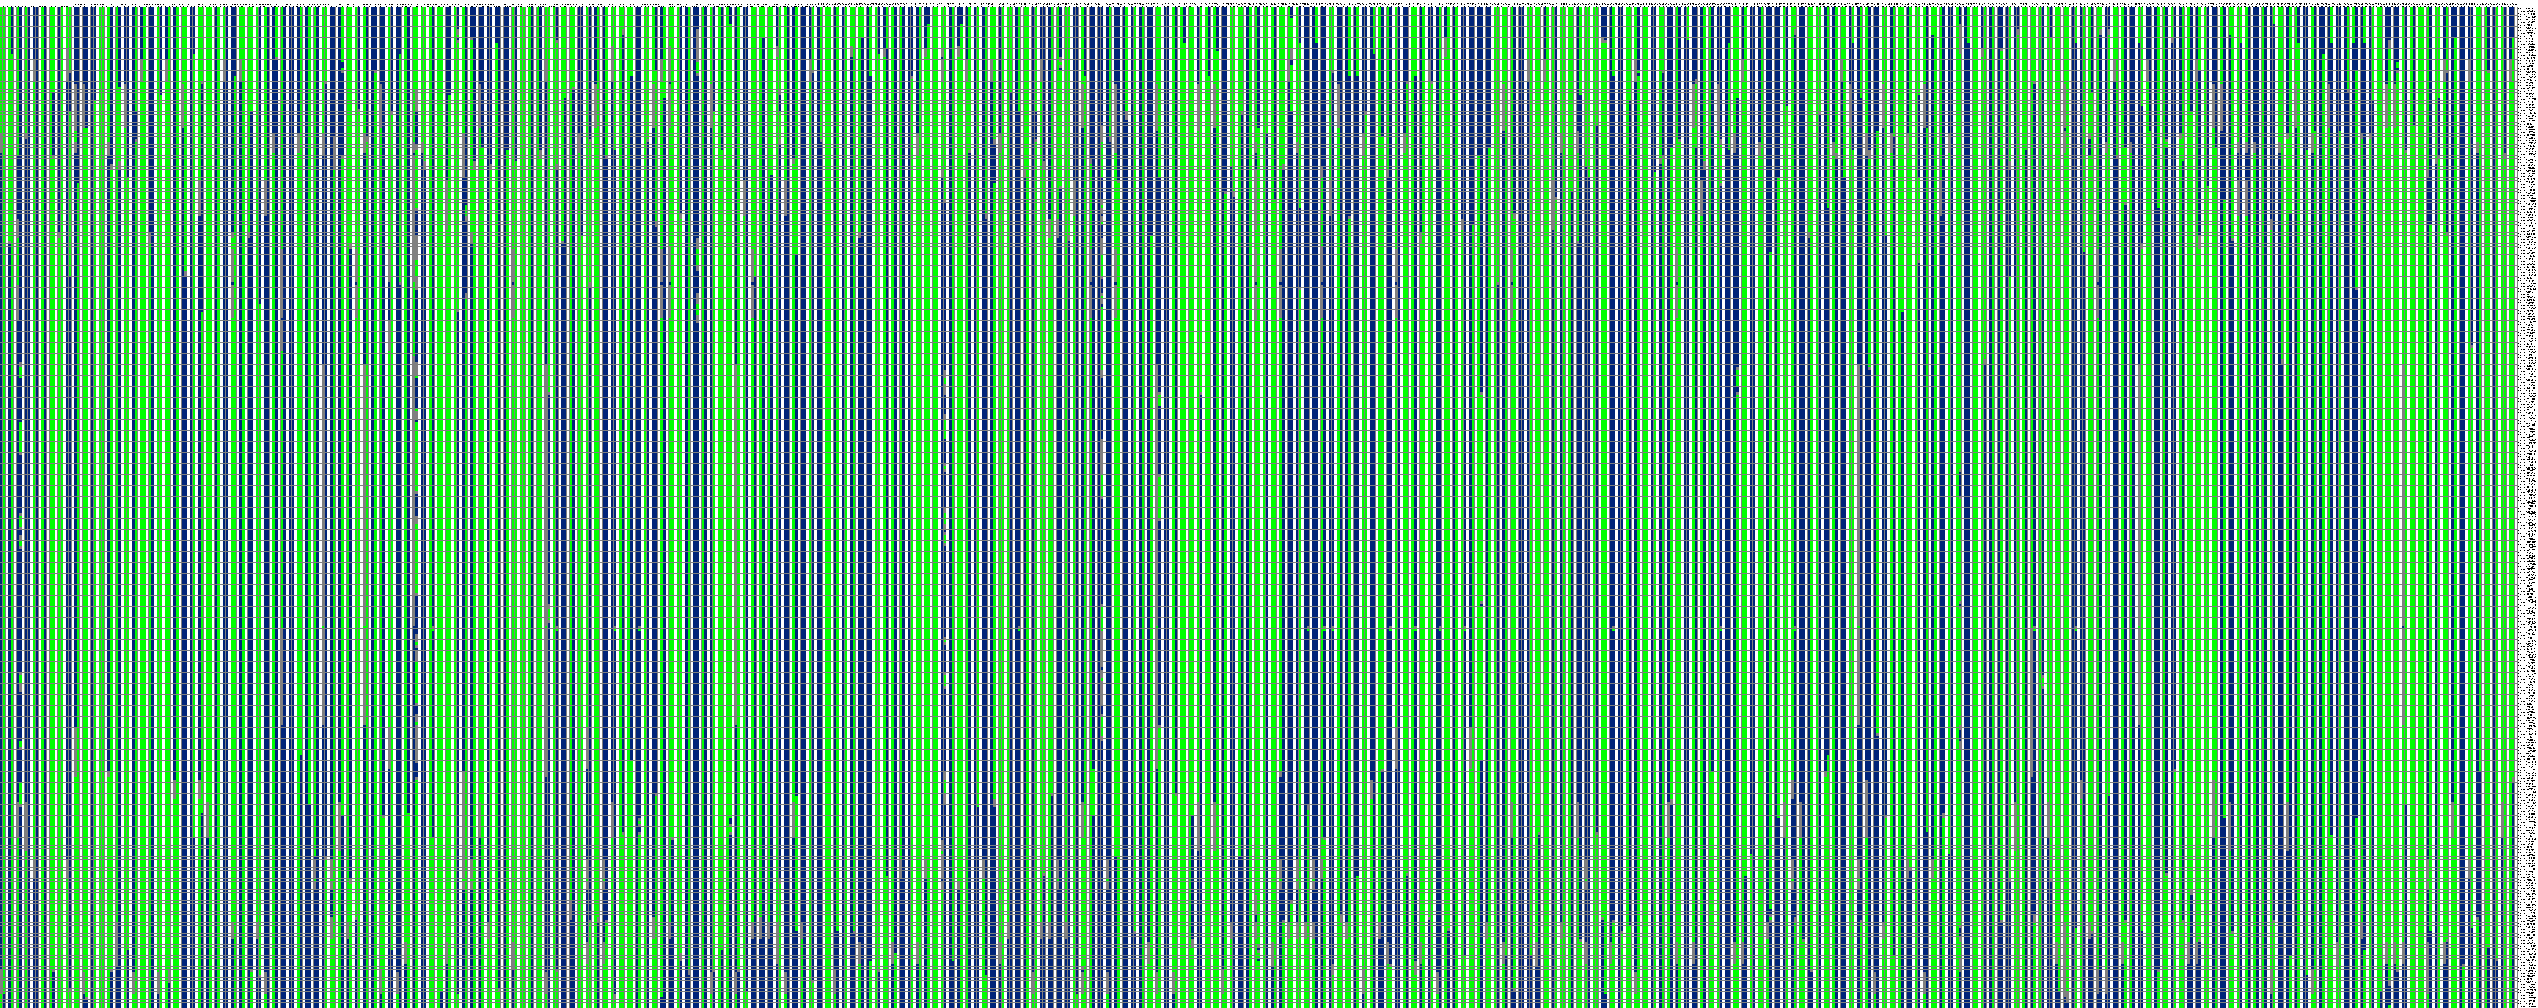
4c. LG3

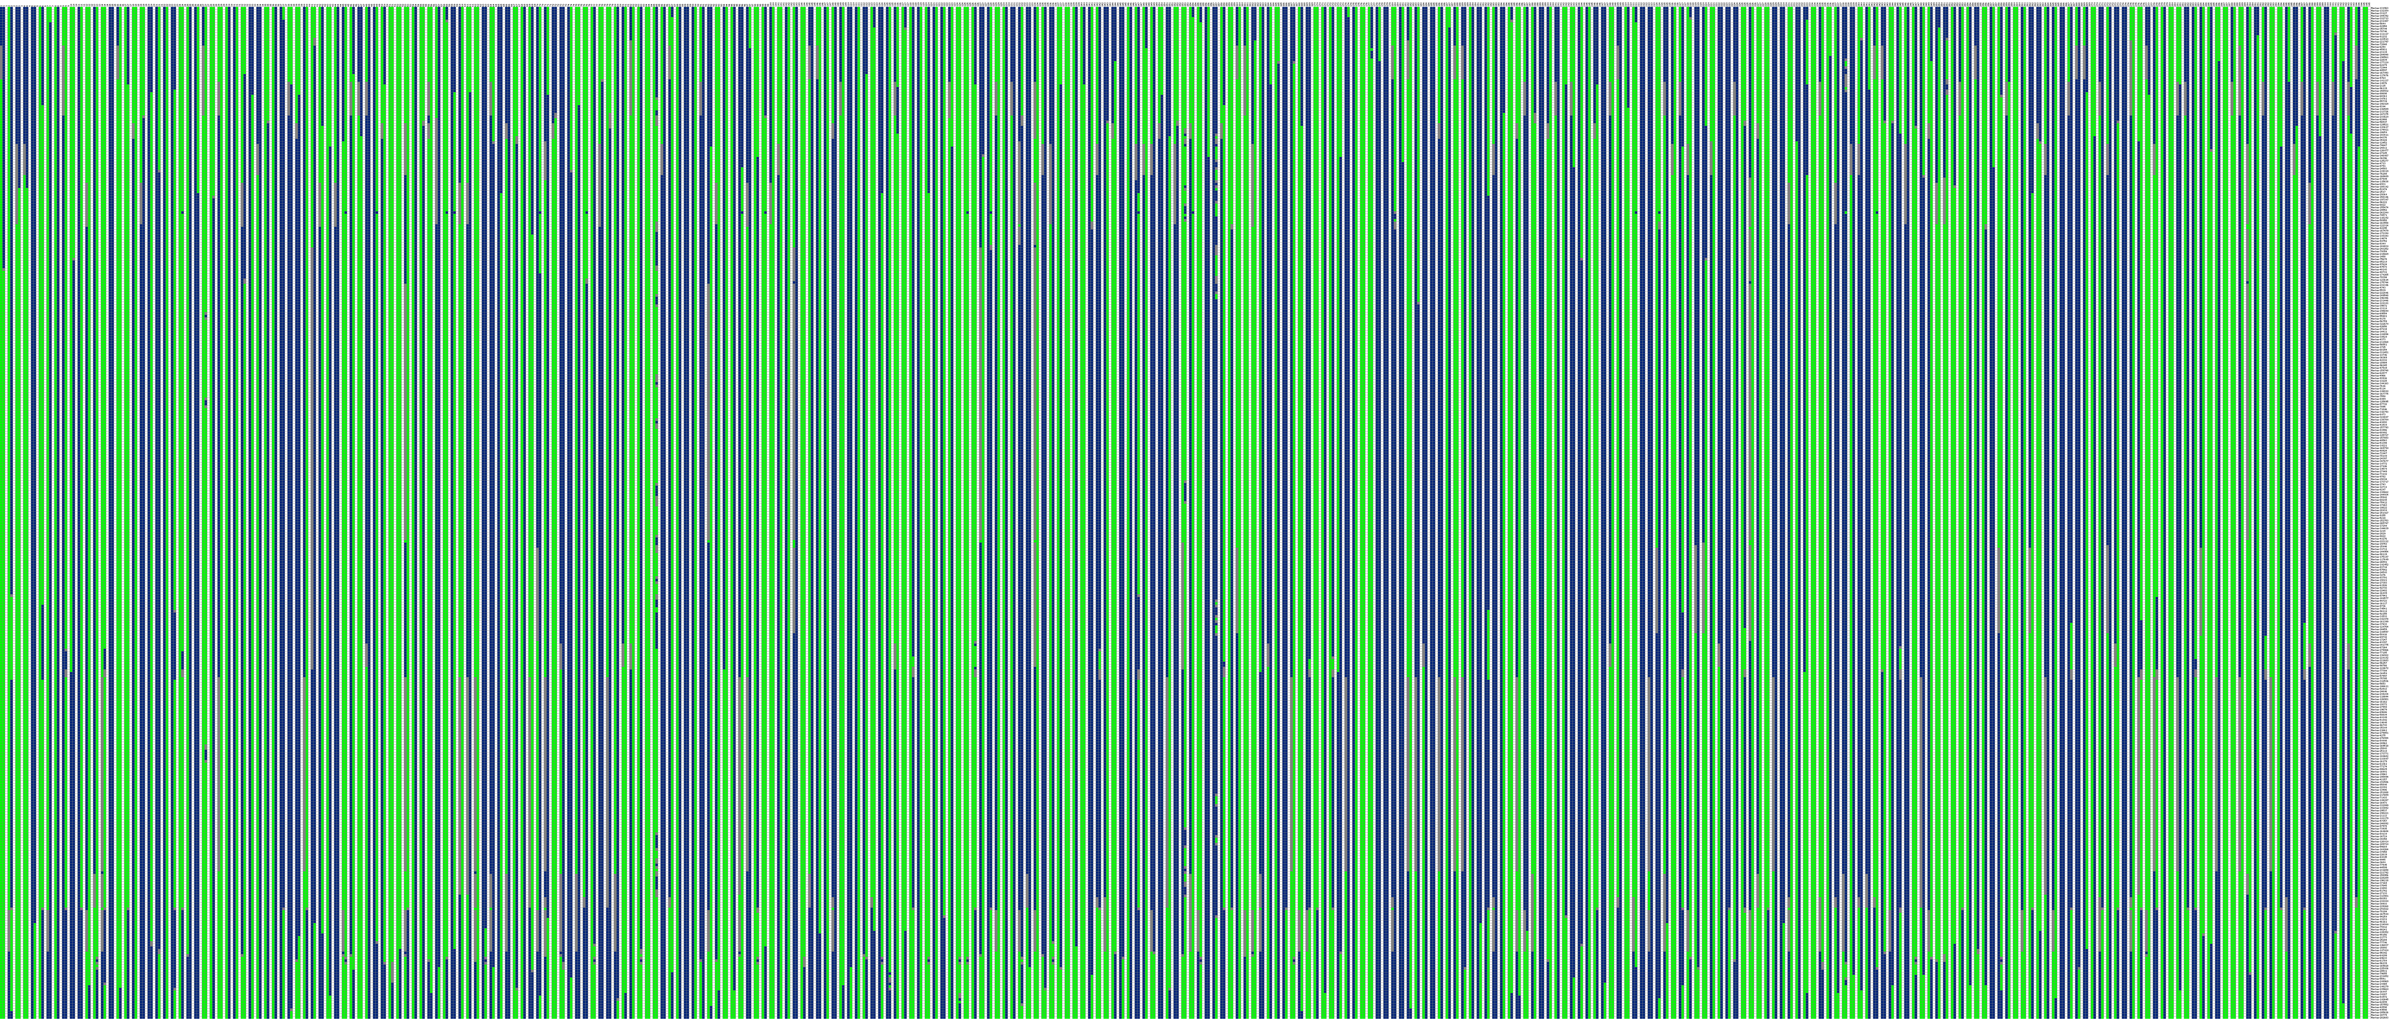
4d. LG4

4e. LG5
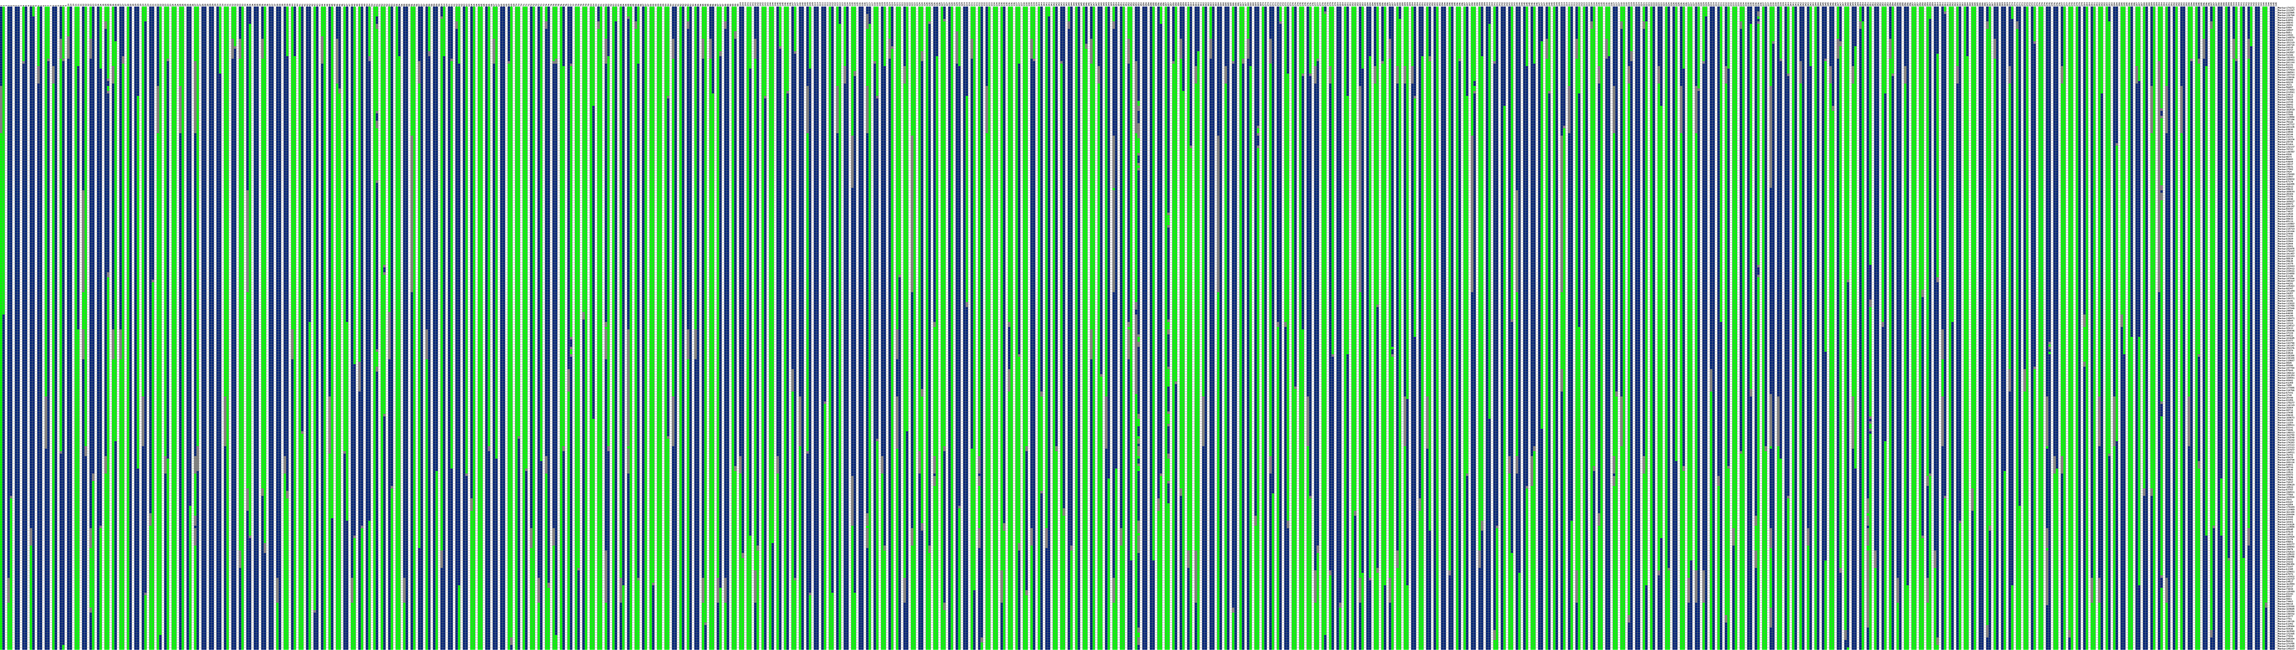

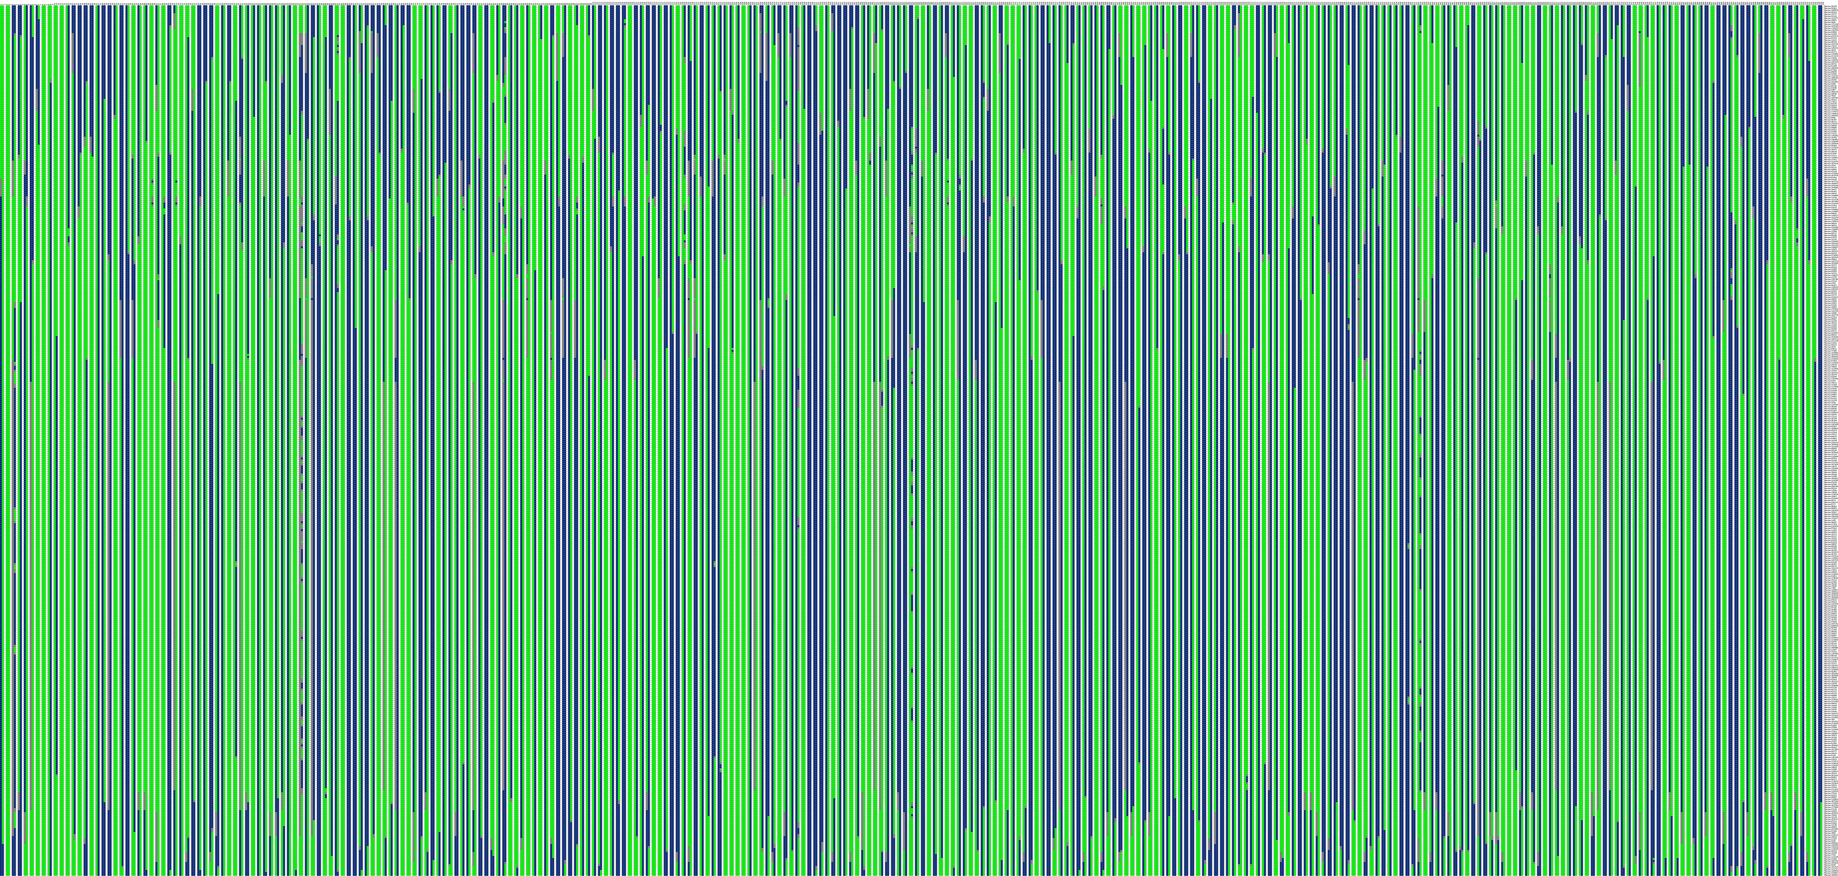
4f. LG6

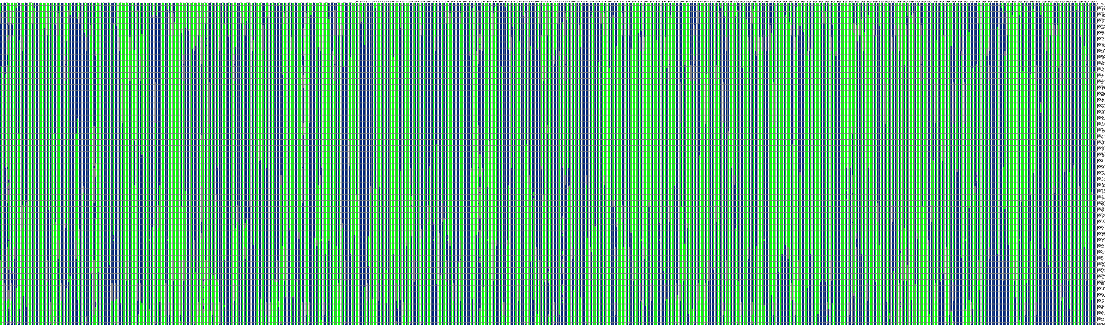
4g. LG7

4h. LG8

4i. LG9

4j. LG10

4k. LG11

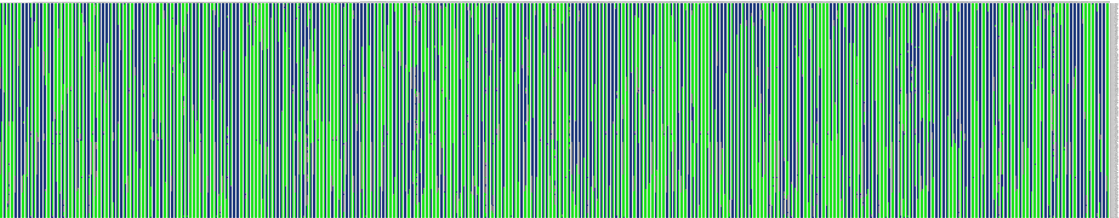
4l. LG12

Figure S4(a-l) Haplotype mapping of 305 F₁ individuals based on 12 linkage groups of integrated maps. In each individual map horizontal line represents a marker and column shows a chromosome in a sample. The first column of the map shows a paternal chromosome and second column as maternal chromosome, and individuals are separated by blank columns. Green color indicates first allele from the parent, blue as the second allele from the parent, white color shows not judged event, and gray indicates missing event. The position where color changes in the same column display reorganization events.

5a. LG1

5b. LG2

5c. LG3

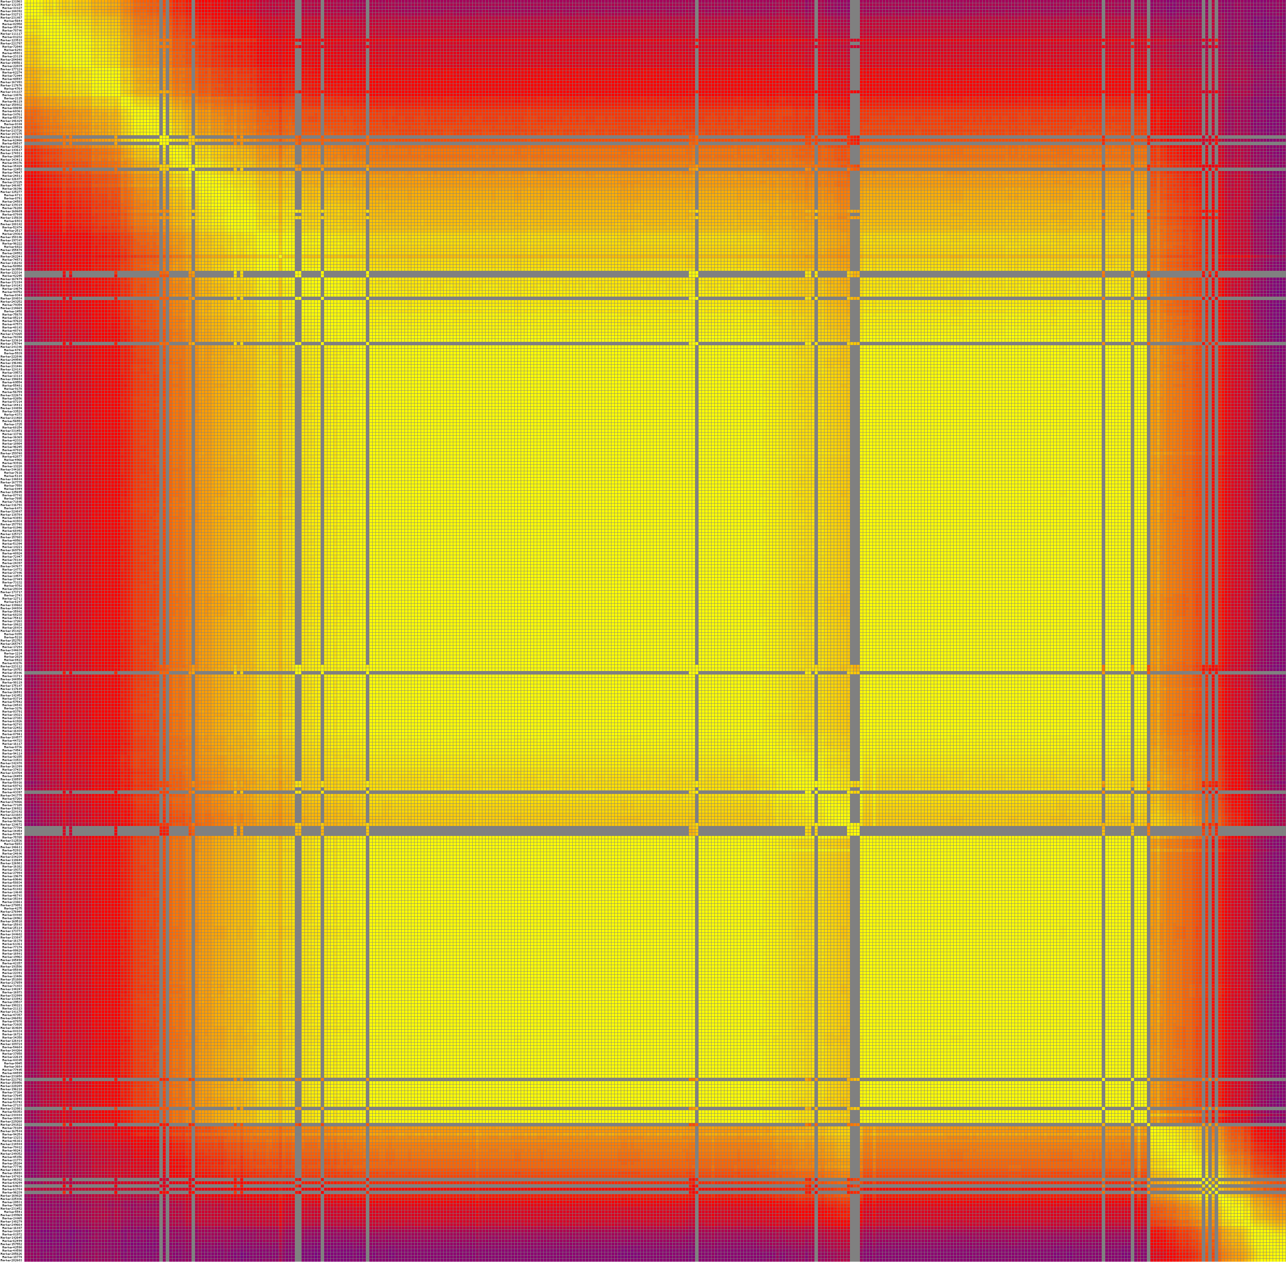
5d. LG4
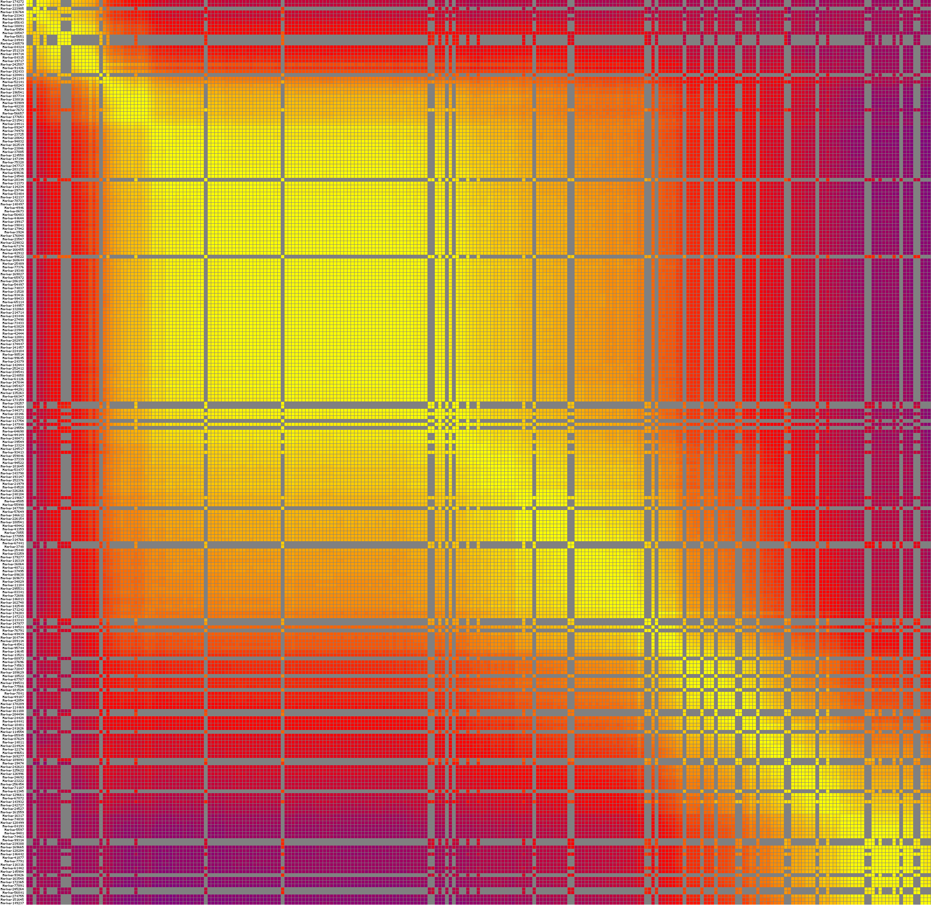
5e. LG5
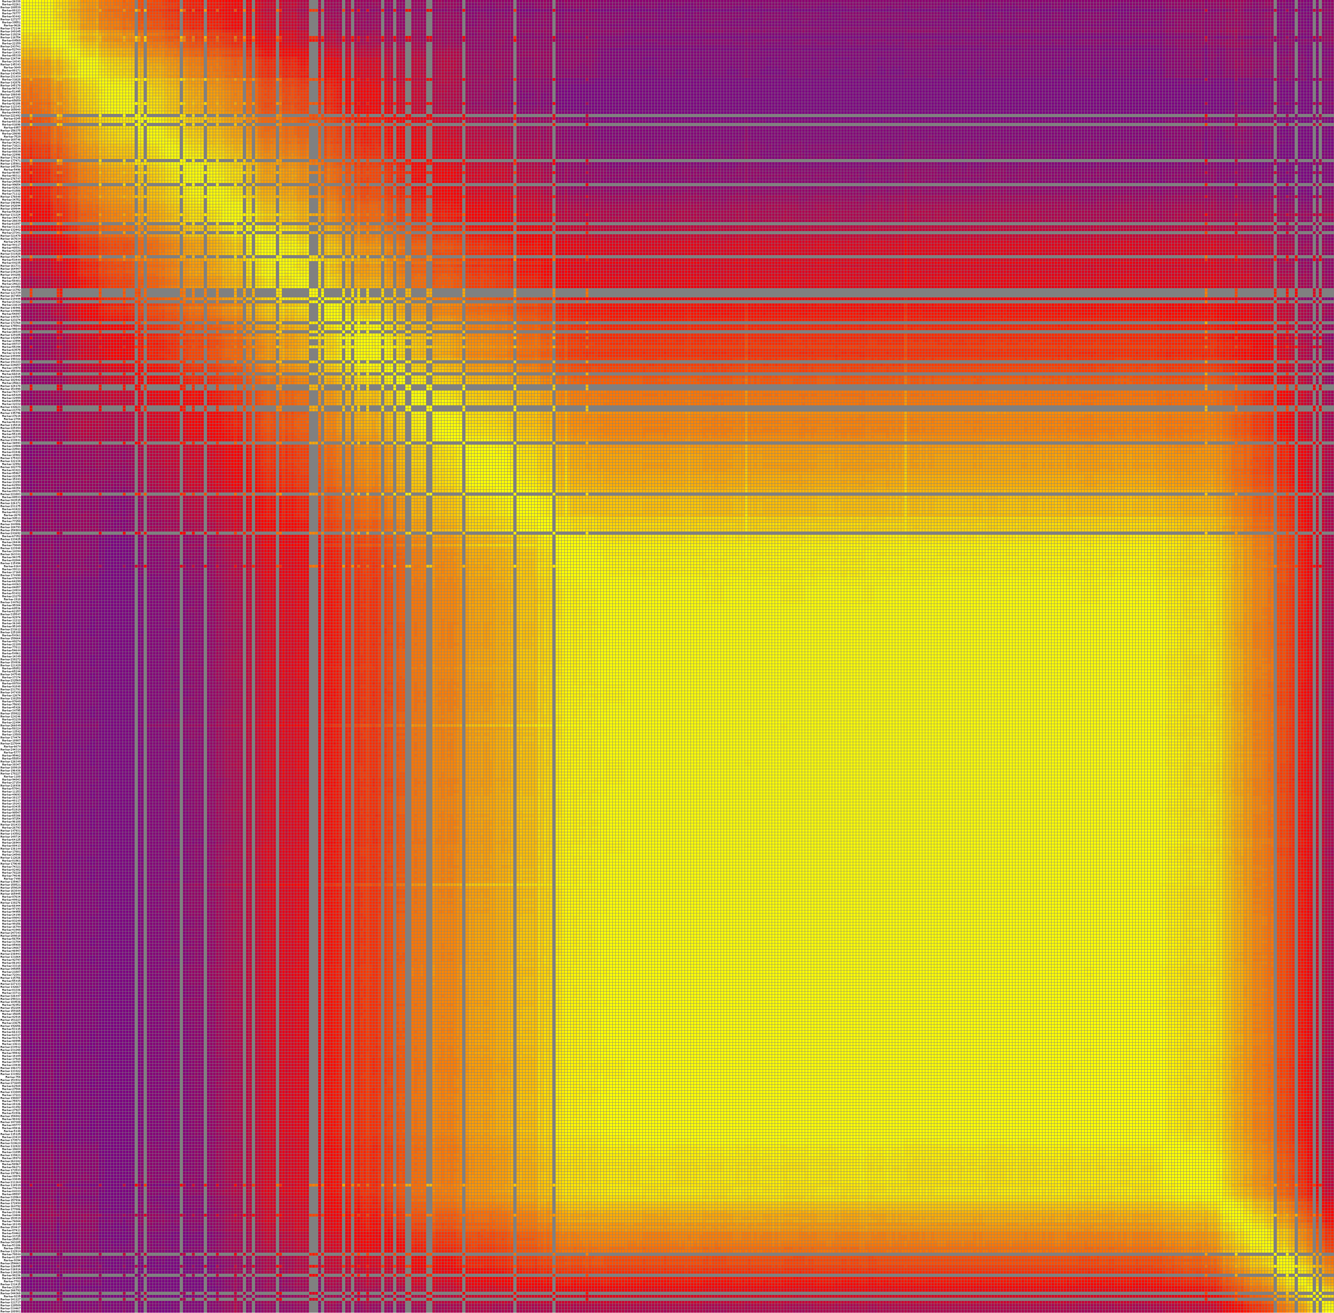
5f. LG6
5g. LG7

5h. LG8

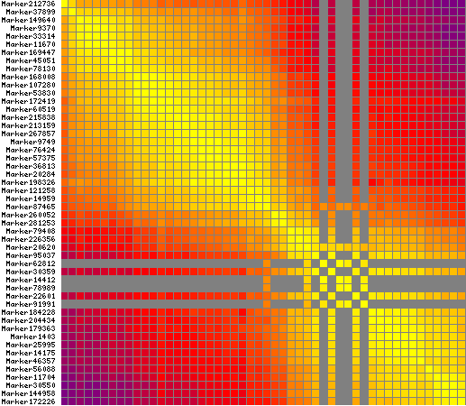

5i. LG9

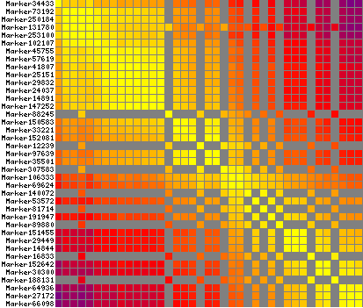

5j. LG10

5k. LG11

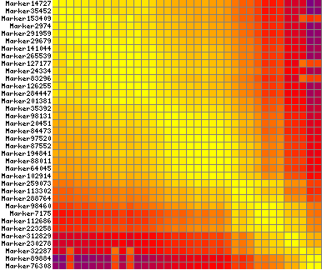

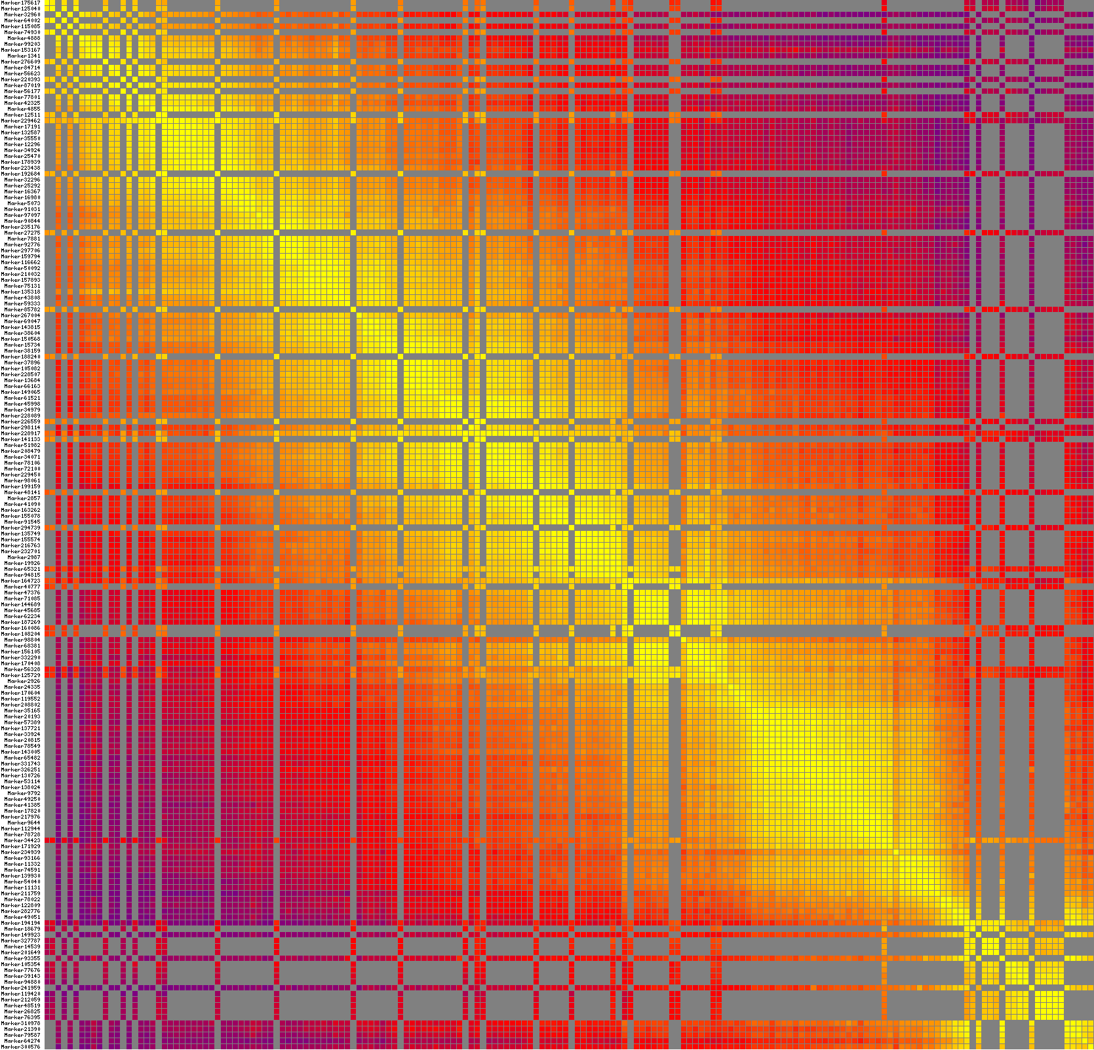
5l. LG12

Figure S5(a-l) Heatmaps of 305 F₁ individuals based on 12 linkage groups of integrated maps. Each row and column represent marker arranged in the order of the map. Every small square show recombination rate between two markers. The color change trend from yellow to red to purple display reorganization rate from small to large. Yellow color indicates closer marker recombination rate, whereas closer the color from yellow to purple farther becomes the recombination rate.

